جامعـة العلـوم التطبيقية الخاصة  كلية تكنولوجيا المعلومات  الواجب الثاني 2024-2    □ CS □ SE □ CCC □ DSAI □ Other |   Due: May. 31, 2025 | APPLIED SCIENCE UNIVERSITY (ASU)  FACULTY OF INFORMATION TECHNOLOGY (FIT)  Second Homework 2024-2  Subject: Cloud Computing Security 1305315  Instructor: Dr.Mahmoud Aljawarneh  I.Qais Alnaamnah
Please Note that You need to complete the project report.

Cloud Security Project Report
Project Title: [Insert Full Project Title Here ]

Project Name : [Automated Security Group Auditing with Lambda Project ]

Project Number: [23]
Student Name | Student ID
Murtaja AL-Khammash | 202230060
Mohammed Abouchelleih | 202210035
Omar Qaza | 202210094
——— | ———

Project Overview and Objectives

Project Description

Serverless solutions used by AWS LAMBDA to check for excessive tolerance rules by EC2 security groups (such as SSH/RDP at 0.0.0/0). The results are registered in CloudWatch This project develops a serverless solution using AWS Lambda to check EC2 security periodically, Groups in your AWS account. Lambda Function Scan As someone who allows unlimited access (0.0.0.0.0/0) with general sensitive connections such as SSH (22) and RDP (3389), Record reviews or prominent findings

Project Goal(s)

1-Automate auditing: Scan all security groups for dangerous intruders.
2-Continuous monitoring: Plan daily scans for CloudWatch events.
3- Least Privilege: Lambda uses minimal IAM permissions

AWS Services Utilized
- Service 1: AWS Lambda
- Service 2: EC2 (Security Group)
- Service 3: CloudWatch (Logs, Events/Event Bridge)
- Service 4 : IAM

Implementation Details
[This section will describe the step-by-step configuration of the AWS resources. Break it down into logical sub-sections based on the major components or services configured. For each subsection, provide a brief description of what was done.]

Component/Service 1 Setup (EC2 Console)
Description: [We created Three Ec2 security Group The First one named CompliantTestSG with default VPC in bounded roles has SSH with port 22 , the connection to the service from "My IP" , The second one named : NonCompliantSSHOpenSG with default VPC with inbounded roles has ssh with port 22 , the connection to the it from "Anywhere IPv4(0.0.0.0/0) " the third one name NonCompliantRDPOpenSG with default VPC and with inbounded role service RDB with port 3389 from ”Anywhere IPv4 (0.0.0.0/0)”. ]
- Key configuration point 1: Security group name: CompliantTestSG
- Key configuration point 2: with default VPC and inbounded roles has SSH with port 22 "
- Key configuration point 3: the connection to the service from "My IP
- Key configuration point 4: Security group name: NonCompliantSSHOpenSG
- Key configuration point 5: with default VPC and inbounded roles has ssh with port 22
- Key configuration point 6: the connection to the it from "Anywhere IPv4(0.0.0.0/0) "
- Key configuration point 7: Security group name: NonCompliantRDPOpenSG
- Key configuration point 8: with default VPC and with inbounded role service RDB with port 3389
- Key configuration point 9: the connection to the it from "Anywhere IPv4(0.0.0.0/0) "

Component/Service 2 Setup (IAM Role)
Description: [we used an already created IAM role named (LabRole).]

- Key configuration point 1: Role Name: LabRole

Component/Service 3 Setup (Lambda)
Description: [Lambda (Python function for auditing logic), we created a lambda function with the name SecurityGroupAuditor, Runtime Python 3.9, used role named LabRole, and used a json code with a timeout of 1 minute.]

- Key configuration point 1: Lambda Function name: SecurityGroupAuditor
- Key configuration point 2: Runtime: Python 3.9
- Key configuration point 3: Role name: LabRole
- Key configuration point 4: jsnon code used with a timeout of 1 minute (code will be provided later on)

Component/Service 4Setup (CloudWatch)
Description: [CloudWatch Logs/Events (Logging and scheduling) we created a rule from EventBridge console named DailySGAuditScheduler pattern defined as ”Schedule.”. in Schedule pattern we selected “cron expression” for testing and the target is set to lambda function .]
- Key configuration point 1: Rule name: DailySGAuditScheduler
- Key configuration point 2: Pattern definition: ”Schedule”
- Key configuration point 3: Schedule pattern : “cron expression”
- Key configuration point 4: Target : Lambda Function

Configuration Screenshots
[This section will provide visual evidence of the key configurations. Refer back to the subsections in Section 2. For each significant configuration, include a screenshot with a descriptive caption.]

Screenshots for [Component/Service 1 EC2 Console]
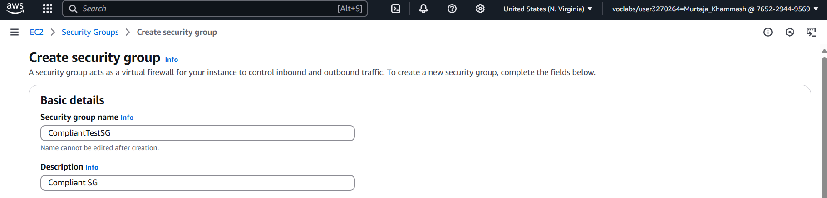
Figure 1: [• Key configuration point 1: Security group name: CompliantTestSG]
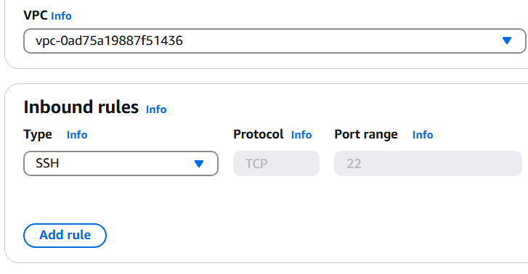
- Figure 2: [Caption for Component 1, Key configuration point 2: with default VPC and inbounded roles has SSH with port 22 "]
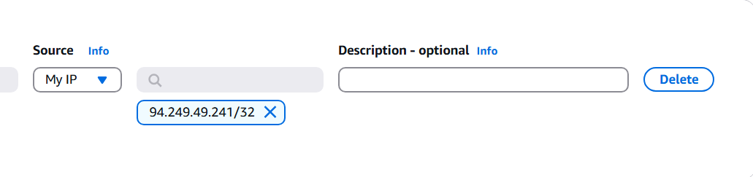
- Figure3 : [Caption for Component 1, Key configuration point 3: the connection to the service from "My IP
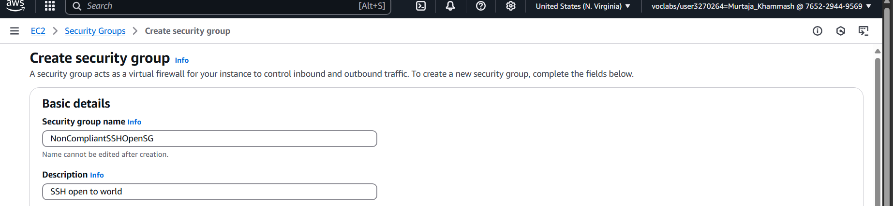
- Figure 4: [Caption for Component 1, Key configuration point 4: Security group name: NonCompliantSSHOpenSG]
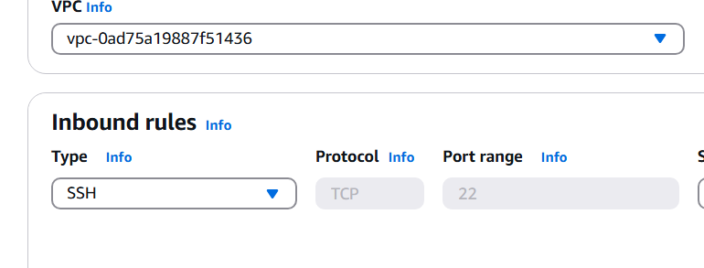
- Figure 5: [Caption for Component 1, Key configuration point 5: with default VPC and inbounded roles has ssh with port 22]

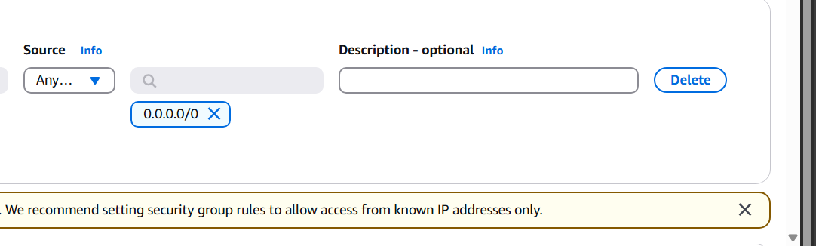
- Figure 6: [Key configuration point 6: the connection to the it from "Anywhere IPv4(0.0.0.0/0) "]
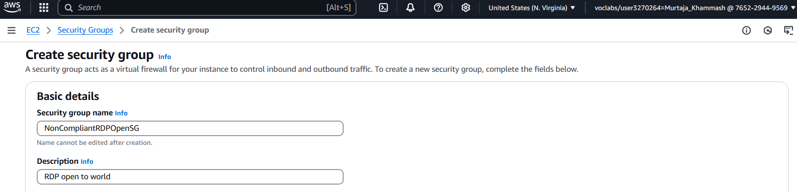
- Figure7: [Key configuration point 7: Security group name: NonCompliantRDPOpenSG]

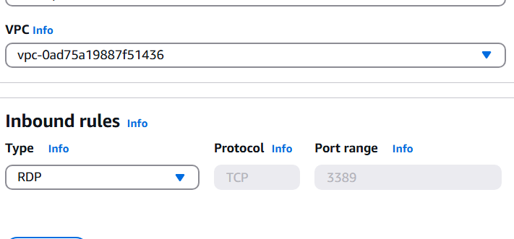

- Figure 8: [Key configuration point 8: with default VPC and with inbounded role service RDB with port 3389]
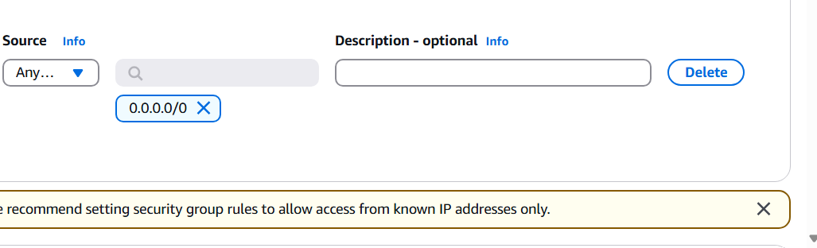
- Figure 9: [Key configuration point 9: the connection to the it from "Anywhere IPv4(0.0.0.0/0)"]

Screenshots for [Component/Service 2 IAM Role]
- 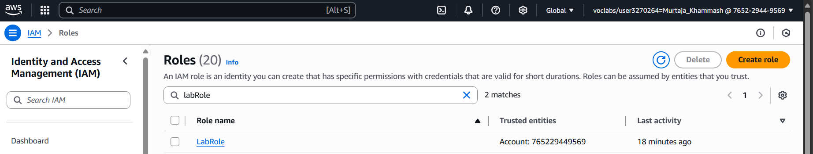Figure 10: [Caption for Component 2 Key configuration point 1: Role Name: LabRole]

Screenshots for [Component/Service 3 Lambda]
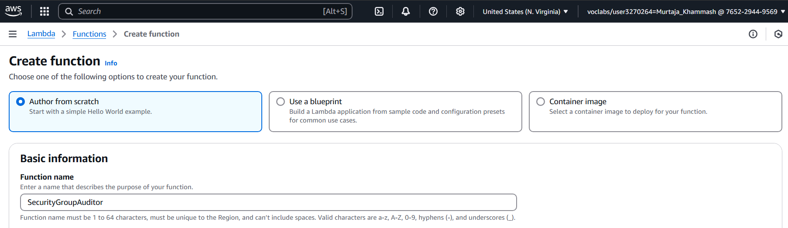

Figure 11: [Key configuration point 1: Lambda Function name: SecurityGroupAuditor]
Figure 12: [ Key configuration point 2: Runtime: Python 3.9]
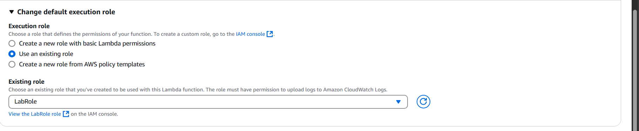
Figure 13: [Key configuration point 3: Role name: LabRole]
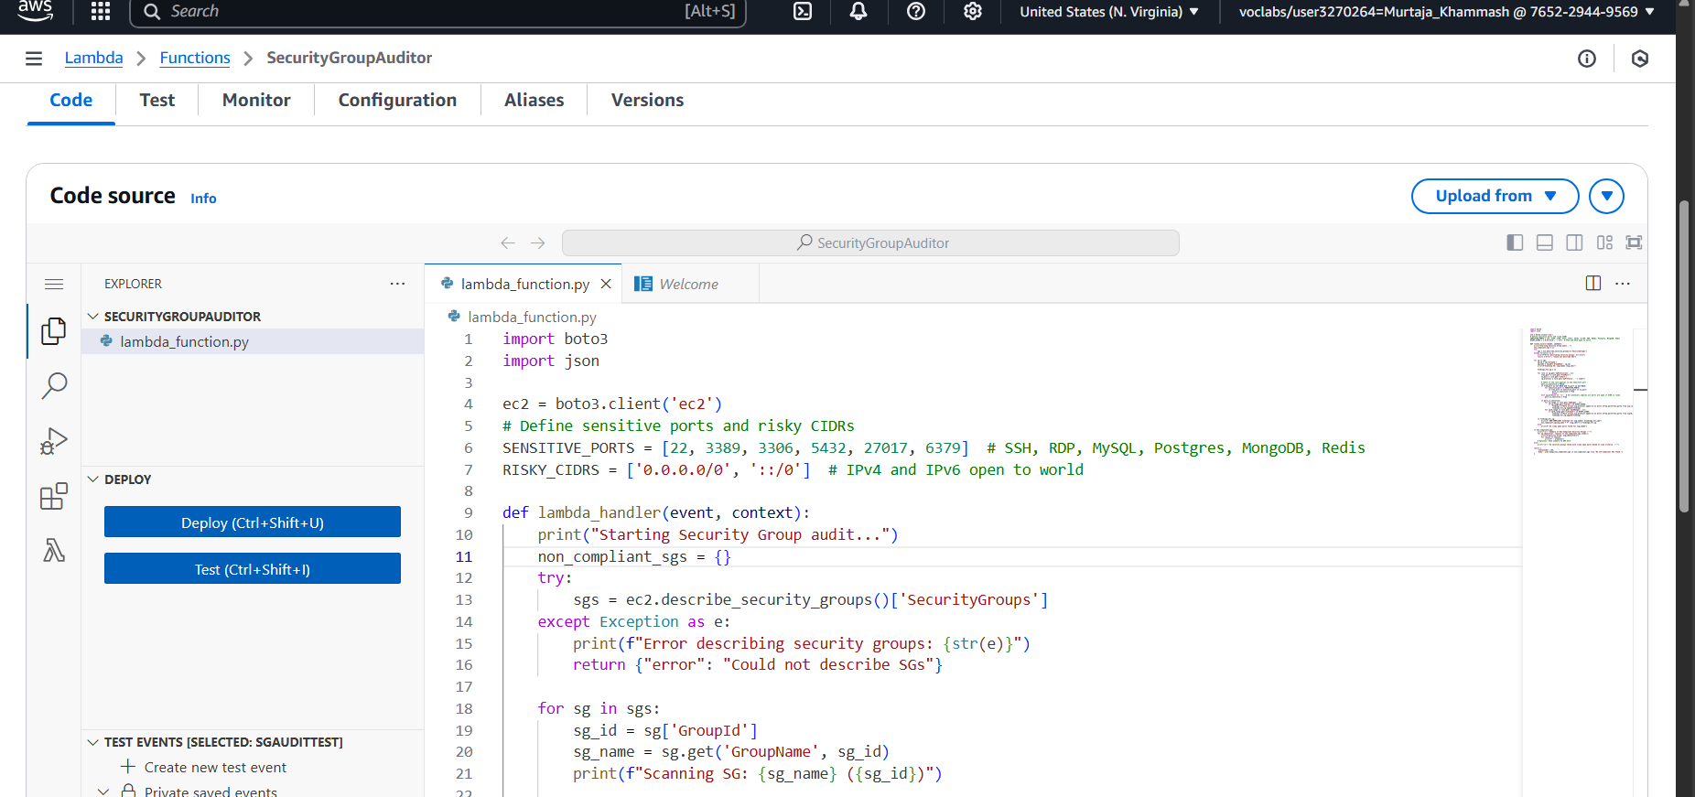
Figure 14: [Key configuration point 4: jsnon code used with a timeout of 1 minute (code will be provided later on)]

Screenshots for [Component/Service 4 CloudWatch]
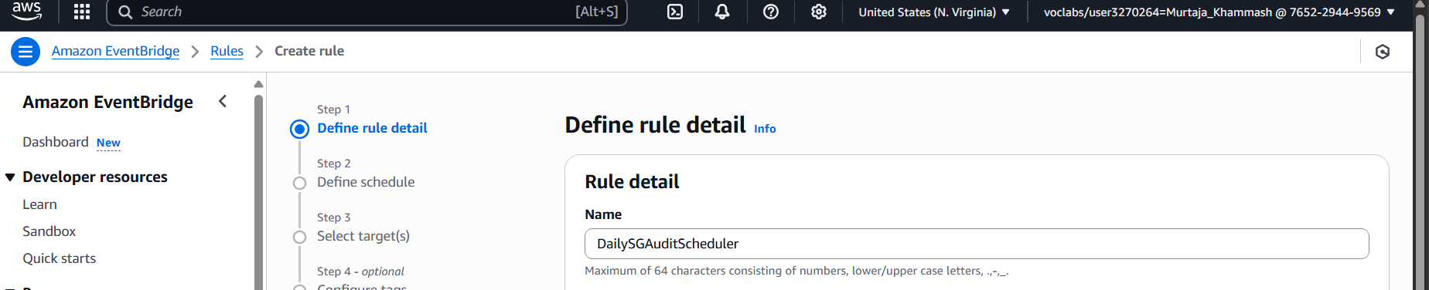
Figure 15: [Key configuration point 1: Rule name: DailySGAuditScheduler]
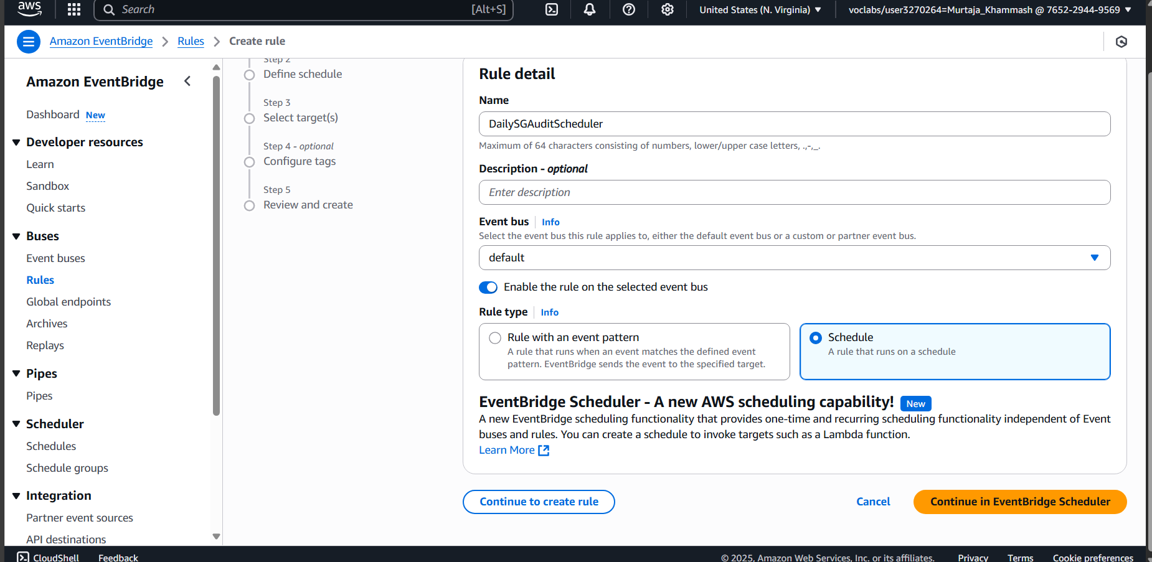
Figure 16: [Key configuration point 2: Pattern definition: ”Schedule”]
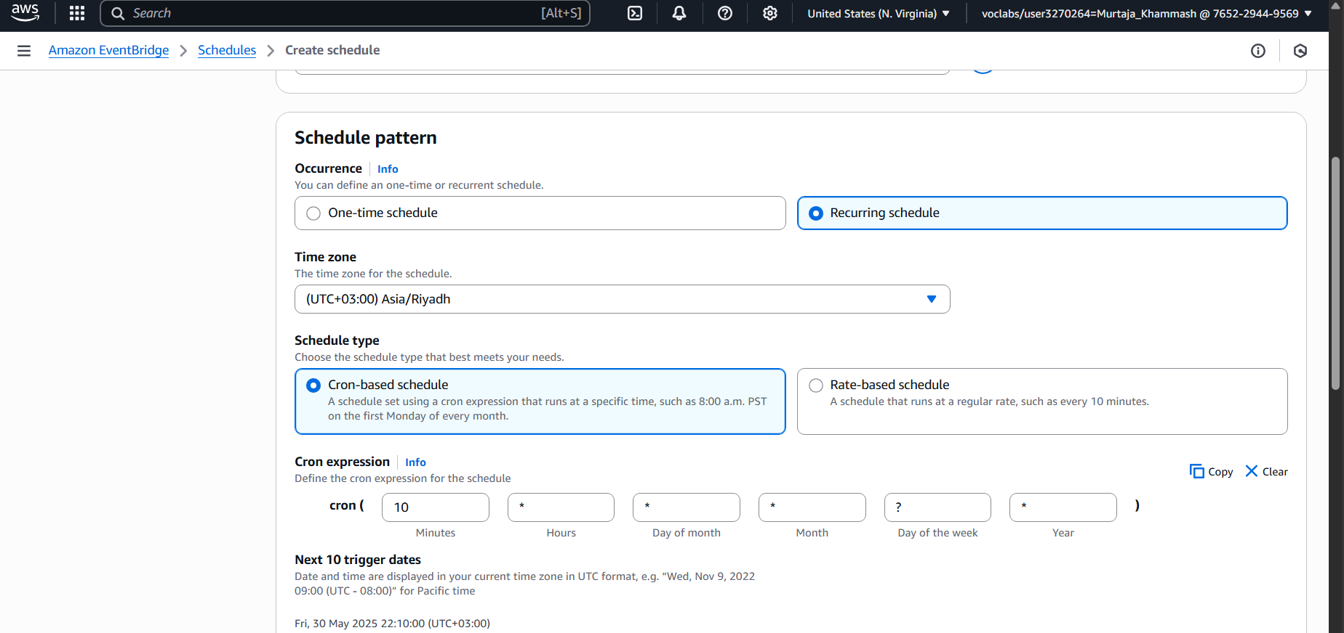
Figure 17: [Key configuration point 3: Schedule pattern : “cron expression”]
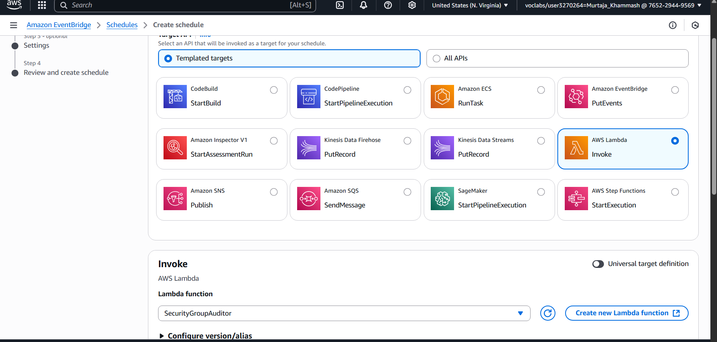
Figure 18: [Key configuration point 4: Target : Lambda Function]]

Testing and Validation
[Describe how you tested the implemented solution and validated that it met the project goals. For each test case, explain the steps taken, the expected outcome, and the actual outcome. Include screenshots of test results where applicable (e.g., CLI output, console messages, successful/failed access attempts).]

Test Case 1: [Brief Description of Test, see output identifying NonCompliantSSHOpenSG and NonCompliantRDPOpenSG with their risky rule]
Test Steps:
- Step 1, Starting test from lambda.
- Step 2, Checking and analysis logs from cloud watch

Expected Outcome: [You should see output identifying NonCompliantSSHOpenSG
and NonCompliantRDPOpenSG with their risky rule]
Actual Outcome: [NON-COMPLIANT findings for NonCompliantSSHOpenSG : ['Rule allows TCP on ports 22-22 from 0.0.0.0/0'] NON-COMPLIANT findings for NonCompliantRDPOpenSG: ['Rule allows TCP on ports 3389-3389 from 0.0.0.0/0'] like what is in the figure 19 , 20 ]

Test Case 2: [CompliantTestSG should have no findings]
Test Steps:
- Step 1,Start testing .
- Step 2 Checking and analysis logs from cloud watch
Expected Outcome: [CompliantTestSG should have no findings]
Actual Outcome: [no findings In logs like in the figure 21 .]

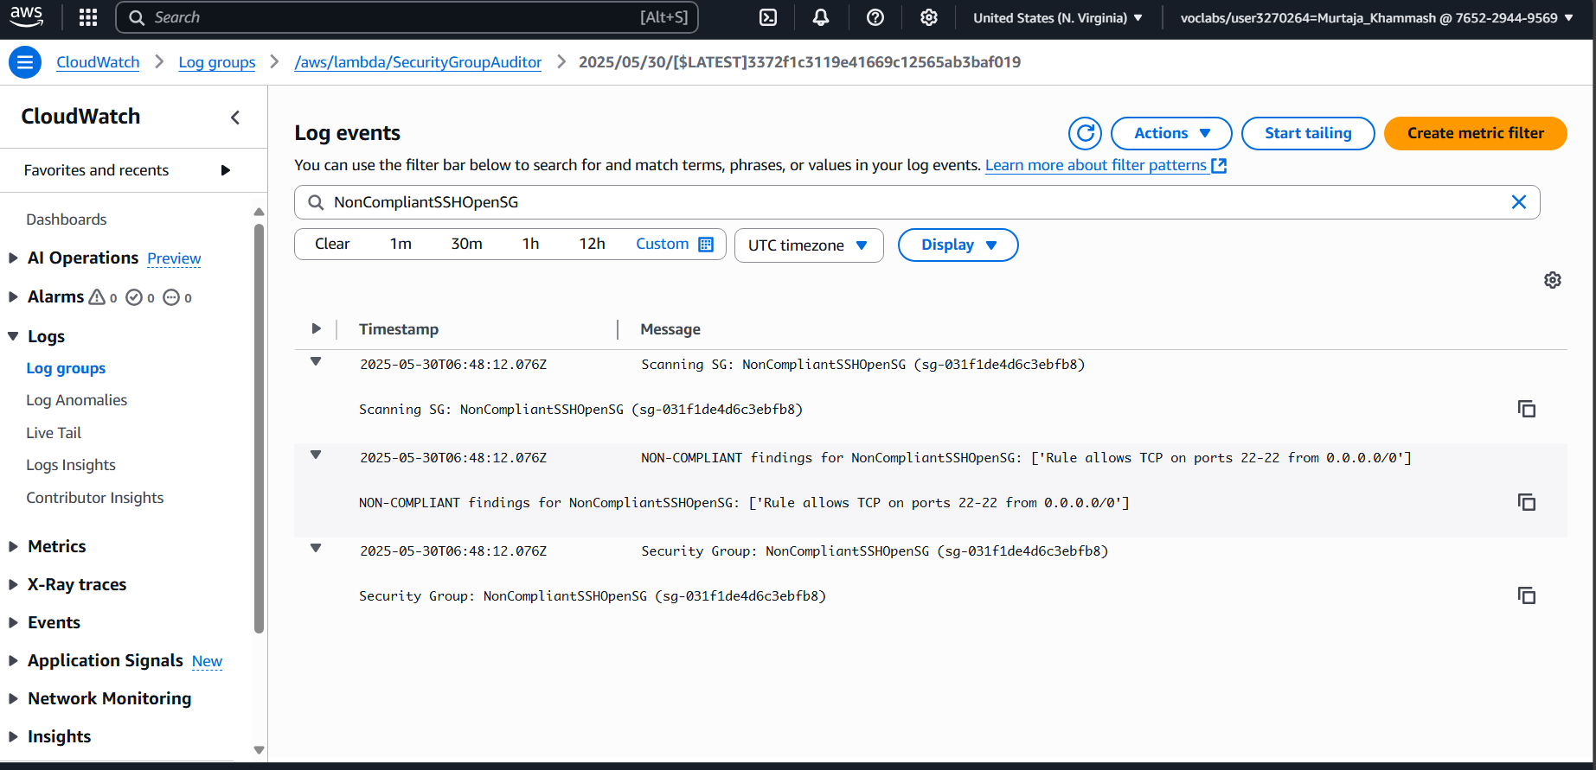 Figure 19: [Brief Description of Test, see output identifying NonCompliantSSHOpenSG with their risky rule.]
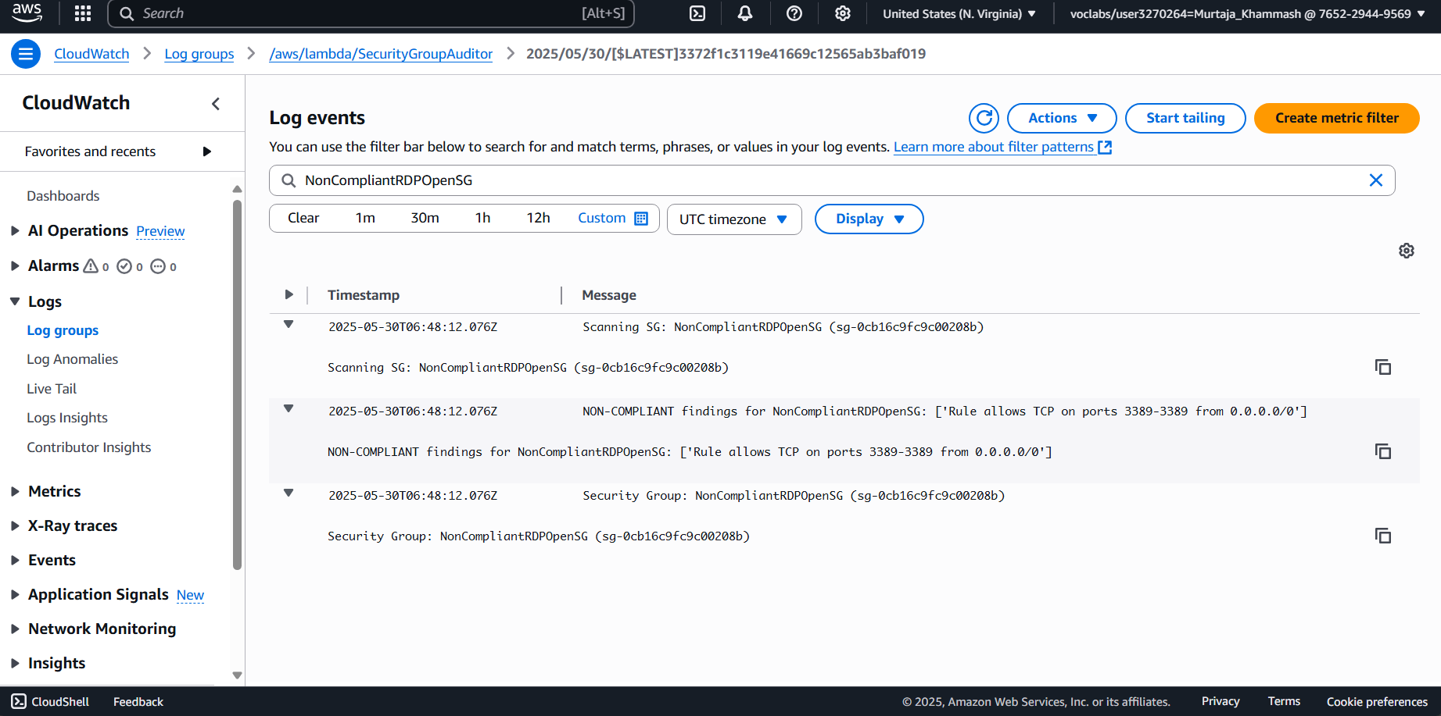
Figure 20: [Brief Description of Test, see output identifying NonCompliantRDPOpenSG with their risky rule]

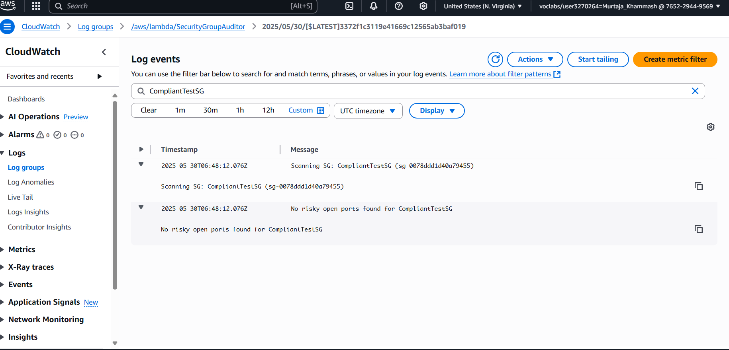 Figure 21: [CompliantTestSG should have no findings.]

Security Learnings and Discussion
[Reflect on what you learned from this project, specifically regarding AWS security principles and practices. Discuss any challenges encountered and how you overcame them. What are the security implications of the configurations you made? How could this solution be improved or extended in a real-world scenario?]

Key Security Takeaways
Learning 1: The principle of least privilege in action:The role of the Lambda function was given only permission descriptions, describing EC2: permission to minimize attack surfaces. This forced critical AWS security best practices to issue minimum required permissions.
- Learning2:Automatic security monitoring: learned how a serverless architecture (Lambda + CloudWatch) enables nearrealtime security testing without maintaining the infrastructure. This is much more efficient than manual checks.
- Learning3:OverRule Risk: The project highlights how often there are misconfigurations such as 0.0.0.0/0 in attacker SSH/RDP connections. Auto-detection reduces exposure duration.Add more specific learnings from the project.
- Learning4 : Logging Meaning: The CloudWatch protocol has formed a non-compliant SG immutable test track that is very important for compliance.

Challenges Encountered
[If you faced any issues, describe them here and how you resolved them. This shows problem-
solving skills.]
1-IPv6 - Support Director: First, the Lambda function is only IPv4 (0.0.0.0/0) and there is no IPv6 (::/0). This was added by adding ::/0 to the Risky_Cidrs list.
Lesson: Always consider both IP formats in your network.
2- Port area logic:
Rules with extensive port areas (port: 20, port: 22) had to be carefully verified to avoid false negatives. This was improved by checking whether sensitive ports are in the area.
3- IAM Policy for creating roles : failed for creating or edit the role or any permission
Lesion : using already created role or ask for high permission.

Security Implications and Best Practices

Risk Reduction: The solution reduces the risk of brute force attacks (such as SSH/RDP) by marking SGS exposing public internet sensitive ports.

Reactive to Proactive: The tool recognizes but is not violated. Manual review is still required.

Enhanced Best Practices: Network Segmentation: Limit public exposure using VPCs and private subnets.

Continuous monitoring: Plan daily audits to record misconceptions at the early stages.

Potential Improvements or Extensions
[Suggest how this setup could be enhanced for a production environment.]
- Improvement1: Improved warning:Integrate into your AWS Security Hub or Slack/MS Team for central alerts.
- Improvement2:ScopeExpansion:Add other risk checks
Improvement3:Compliance Mapping:Tag knowledge using the compliance framework

Conclusion

The project successfully automates the detection of excessive security groups using AWS Lambda to reach the goal of an ongoing security obligation. The most important findings include the importance of the most privileged IAM role, the efficiency of serverless testing, and the risk of public multiplier management ports. The solution is fundamental but can be scaled with automatic repair and integration for use of corporate degrees.

Appendix (Optional)
[If you have lengthy code snippets (e.g., full Lambda function code, complex IAM policies,
CloudFormation templates) that would clutter the main sections, you can place them here.]

Appendix A: [Full Lambda Function Code for X (if applicable)]

import boto3
import json

ec2 = boto3.client('ec2')
# Define sensitive ports and risky CIDRs
SENSITIVE_PORTS = [22, 3389, 3306, 5432, 27017, 6379] # SSH, RDP, MySQL, Postgres, MongoDB, Redis
RISKY_CIDRS = ['0.0.0.0/0', '::/0'] # IPv4 and IPv6 open to world

def lambda_handler(event, context):
print("Starting Security Group audit...")
non_compliant_sgs = {}
try:
sgs = ec2.describe_security_groups()['SecurityGroups']
except Exception as e:
print(f"Error describing security groups: {str(e)}")
return {"error": "Could not describe SGs"}

for sg in sgs:
sg_id = sg['GroupId']
sg_name = sg.get('GroupName', sg_id)
print(f"Scanning SG: {sg_name} ({sg_id})")

findings_for_sg = []

for rule in sg.get('IpPermissions', []):
from_port = rule.get('FromPort')
to_port = rule.get('ToPort')
ip_protocol = rule.get('IpProtocol', '').lower()

# Check if the rule applies to any sensitive port
port_is_sensitive = False
if from_port is not None and to_port is not None:
for sensitive_port in SENSITIVE_PORTS:
if from_port <= sensitive_port <= to_port:
port_is_sensitive = True
break
elif ip_protocol == '-1': # All protocols implies all ports are open if CIDR is risky
port_is_sensitive = True

if port_is_sensitive:
for ip_range in rule.get('IpRanges', []):
if ip_range.get('CidrIp') in RISKY_CIDRS:
finding = f"Rule allows {ip_protocol.upper()} on ports {from_port}-{to_port} from {ip_range['CidrIp']}"
findings_for_sg.append(finding)
for ipv6_range in rule.get('Ipv6Ranges', []):
if ipv6_range.get('CidrIpv6') in RISKY_CIDRS:
finding = f"Rule allows {ip_protocol.upper()} on ports {from_port}-{to_port} from {ipv6_range['CidrIpv6']}"
findings_for_sg.append(finding)

if findings_for_sg:
print(f" NON-COMPLIANT findings for {sg_name}: {findings_for_sg}")
non_compliant_sgs[sg_name + f" ({sg_id})"] = findings_for_sg
else:
print(f" No risky open ports found for {sg_name}")

if non_compliant_sgs:
print("\n--- Summary of Non-Compliant Security Groups ---")
for sg_identifier, reasons in non_compliant_sgs.items():
print(f"Security Group: {sg_identifier}")
for reason in reasons:
print(f" - {reason}")
# Optional: Send summary to SNS here
else:
print("\n--- No security groups found with risky open ports based on scan criteria. ---")

return {
'statusCode': 200,
'body': json.dumps(non_compliant_sgs if non_compliant_sgs else "No non-compliant SGs found.")
}

Listing 1: Full Python Code for Lambda Function [SecurityGroupAuditor]

Appendix B: [Full IAM Policy JSON for Y (if applicable)]
{  } | // Paste full IAM policy JSON here
4
5
6
Listing 2: Full IAM Policy JSON for [Policy Name

Good Luck

